Submission Form E&L

Document Number | 002-FOR-9148867 | Legacy Number | 1-P-SC-FOR-9148867; Mod. SOP/COM/001.U
Version | 2 | Status | Effective
Effective date | 11-Feb-2026 | Periodic Review Date | 11-Feb-2029
Author | Laura D Alessandra (W9WJ) | Departments | GE - General
eQMS Scope | EUITVI - Eurofins Biolab Srl (Vimodrone)
Quality System | EUITVI GMP  EUITVI ISO 9001 : 2015

Electronic Signatures
Reviewer(s):
Andrea Carrettoni (PANC)
Simone Carrara (PSC2)
; Andrea Carrettoni (PANC) - Reviewed on 14-Jan-2026 03:39 PM UTC
Simone Carrara (PSC2) - Reviewed on 21-Jan-2026 07:01 AM UTC

Approver(s):
Sara Poggi (V2WZ)
, Sara Poggi (V2WZ) - Approved on 10-Feb-2026 09:08 AM UTC

Revision Log for versions before 3rd December 2025
Date | Rev. | Description ###AUTOREVLOG### | Author(s)
Jan 2, 2024 | 1 | Prima emissione. | EU P QC IT ETQ DOC CONTROL

Revision Log for versions after 3rd December 2025
Document Version Reason

Version 2, Effective Date: 11-Feb-2026

Aggiunto nuovo indirizzo e-mail e orari di ricevimento; Dedicata una tabella ai campioni relativi alle stabilità; Aggiunta nota sulle spedizioni <100kg; Riformattate tabelle

SUBMISSION FORM for Extractables and Leachables
IMPORTANT: all the mandatory fields (*) must be completed, if not, this could lead to a delay of the analytical activities
Address:
Eurofins Biolab Srl
Via Bruno Buozzi 2, 20055 Vimodrone, Italy
Phone: +39 02 9294260
Please note that deliveries are allowed between 8.00am and 5.00pm from Monday to Friday and from 8.00am to 11.00am on Saturday.
For any type of issue please contact: DG_CIT005_StaffELPackTest@bpt.eurofinseu.com
SENDER INFORMATION
Company*
Company Site
Sender name and surname*
Sender phone and email address

STORAGE INFORMATION
Transport temperature | Controlled room temperature  (15°C-25°C ) ☐ |  |  | Not relevant at delivery ☐ |  |  | Refrigeration(5°C±3°C) ☐ |  |  |  | Freezer -20°C ☐ |  |  |  | Freezer -80°C ☐
Storage Temperature* | Room temperature (15°C-25°C) ☐ |  |  |  |  | Refrigeration (5°C±3°C) ☐ |  |  | Freezer -20°C ☐ |  |  |  |  | Freezer -80°C ☐
Sample type | Active product  ingredient ☐ | Process item (Single/Multiples Use system) ☐ |  |  |  | Raw material ☐ | Drug product ☐ |  |  | Packaging ☐ |  |  | Medical device ☐ |  |  |  | Other☐
Only check if applicable | Classified as GMMO (genetically modified micro-organism) ☐ |  |  |  |  |  | Antineoplastic/Cytotoxic/Cytostatic agent ☐
Material Safety Data Sheet (MSDS) included¹* | MSDS is attached to the shipment (Mandatory) ☐ |  | H300 fatal if swallowed ☐ |  | H310 fatal in contact with skin☐ |  |  | H310 fatal if inhaled ☐ |  | H340 may cause genetic defects ☐ |  | H350 may cause cancer ☐ |  |  |  | H360 may damage fertility or unborn child ☐
¹ For drug products, drug substances, reagents and raw materials is responsibility of the sender to include in the shipment the MSDS. In case of missing information the materials won’t be managed by our samples operator until this data will be provide

SAMPLES RETURN OR DISPOSAL
Disposal of the samples after testing is complete | Return – unused only and dispose used ☐ | Return all ☐ | Dispose all ☐
The missing of the above information will be considered as “dispose all” – In case of “return” a supplemental fee could be charged.

Please Provide the following information exactly as you would like it to appear on the final report.

SAMPLES INFORMATION (not for human use, samples will be used for analytical testing)
Quotation* |  |  | Purchase order
Samples’ name * | Lot/Batch* | Study Code* | Quantity* | Volume/weight (mL/mg) | Manufacturing date

STABILITY STUDY INFORMATION (fill in this part only if a stability study is expected)
Checkpoints* | Samples’ name | Quantity per checkpoint* | Temperature* | Position*
Sample delivery instructions
Samples shall be delivered properly packaged (see Fig. 1) under the Sender responsibility. If applicable, safety directions and hazard statements shall be placed in a visible way on the external side of the package. Every sample/material shall be sent with its MSDS. Missing MSDS or proper information for samples handling may cause the cessation of on-going activities and represents a failure to comply by the Customer with information and co-ordination obligations required by the service provider. If sent samples include more batches / timepoints or different samples, please separate them inside the package. If more analysis is requested, please send separate aliquots. The samples and customer supplied materials will be stored for 1 month starting from the end of the analyses after which no retained samples and disposable will be kept. The Customer may request an extension of the conservation of all or part of the materials for a further period, or their restitution; a suitable agreement shall be drafted in this case. Samples received without a regular purchase order for their analysis, will be disposed of within one month after receiving them and related costs charged to the Customer.

Shipments, customs levies or other expenses including bank charges will be charged in the invoice. This form filled with information required shall be included with samples, missing information may prevent the starting of the activity and cause delayed. 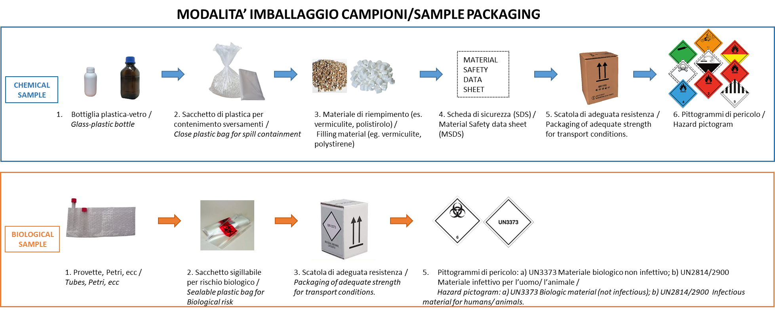
Fig. 1 –Sample packaging instructions.

IMPORTANT: Please note that customers delivering samples weighing more than 100 kg must use a courier with a truck equipped with a hydraulic tail lift or a pallet truck to handle heavy packages.

Offer provided by Eurofins Biolab
Name of the shipped samples as indicated on the labels inside the box. The name of the item should be in alignment with the E&L study protocol. (E.g. Rubber stoppers)
Code provided with the protocol (E.g. STULV25AAxxxx, STULV24AAxxxx, STUDA25AAxxxx etc.)
E.g. T2 months, T60 days, T12 months, etc.
E.g. Upright, Horizontal, Inverted, etc.

